CURRICULUM VITAE

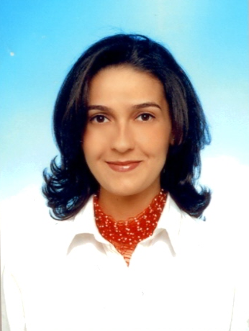

PERSONAL INFORMATION

Name : Özlem İRİTAŞ
Title : Expert on Forests and Water Issues
Date of Birth : 31.05.1977
Marital Status : Married- 2 children
E-mail Address : oiritas@gmail.com

EDUCATION

1999 - 2002 Post graduate, Gazi University, Institute of Science, Ankara, Turkey, http://gazi.edu.tr/
1994 - 1998 Undergraduate, Environmental Engineering, 19 Mayıs University, Samsun, http://www.omu.edu.tr/

PROFESSIONAL EXPERIENCE

December 2015- (Going on) Advisor of General Director of Water Management, Ministry of Forestry and Water Affairs
March 2012- December 2015 Advisor of Deputy Minister, Ministry of Forestry and Water Affairs
September 2010- March 2012 Advisor of Undersecretary, Ministry of Forestry and Water Affairs
June 2010- September 2010 Branch chief of European Union and Coordination, Ministry of Environment and Forestry, DG Environmental Management.
December 2007- June 2010 Expert, Advisor of General Director of Environmental Management, Ministry of Environment and Forestry

March 2007- December 2007 Assistant Expert, Cabinet to the Minister, Ministry of

Environment and Forestry

December 1998- January 2004 Engineer, DG Environmental Impact Assessment, Ministry of

Environment

TRAINING

- International Seminar, Disaster Management, United States Forest Service, 2013.
- Course for Occupational Safety Specialists, Ministry of Labor and Social Security, 2012 (Certificated Specialist)
- Course, Ankara University European Research Center, Basic European Union Training, 2011.
- Seminar on Managing Change in Public Administration, European Institute of Public Administration, 2007, Maastricht, Netherland, http://www.eipa.nl/.
- Seminar, Project Cycle and Management, TODAİE, http://www.todaie.gov.tr/ 2007, Ankara.
- Course, ISO 14001, Inspector of environmental management system 2003, TSE, Ankara
- Course, Open Geodata Interoperability Specifications, 2000, Ankara
- Workshop-METAP- 'Strengthening the EIA System of Turkey' Project, 2000, Antalya
- Technical School for local authorities, 2000, Ankara
- Seminar, ISO 14001-Environmental Management System, 1999, Ankara
- Course on Windows 95, Winword, Excel, AutoCAD R-12 1998, Samsun
- English Course, Graduated, Ankara University TÖMER, Turkish and Foreign Language Research and Application Centre, http://www.tomer.ankara.edu.tr/ 1996-1998, Samsun

INTERNATIONAL
EXPERIENCE

- International Seminar on Disaster Management, United States Forest Service, 2013, CA/WA,USA.
- Study visit, 'Capacity building on water quality monitoring, EU project', 2013, Netherland.
- Study visit, Turkish Environmental Information Exchange Network (TEIEN) Project, 2009, Poland.
- Study visit for pyrolisis technology, Adventus Development LLC, 2008, California-USA.
- Regional Meeting of World Water Forum, 2008, Jordan.
- Seminar on Managing Change in Public Administration, European Institute of Public Administration, 2007, Maastricht, Netherlands.
- Workshop, METAP-EIA Project, Training the trainers, 2000, Tunisia.

PUBLICATIONS:

Post graduate thesis, “Sorption of volatile organic compounds in clay and clay-sand layers in series",
2002.
Dissertation, “ Energy production by gasification of waste and evaluation of its environmental
impacts", 2010.

FOREIGN LANGUAGE English

AREA OF INTERESTS

Transportation of volatile organic compounds, Gasification, Energy from wastes, Environmental Impact Assessment, Occupational Safety, Environmental Management.

